LAB REPORT – 3
PART A - MULTIPLEXER

NAME : Basireddy Khyathi Sri
ROLL NO : 2023102065
GROUP : 6
TABLE : 3

Objective:
I. Design 4:1 multiplexer using basic logic gates
II. Verify MUX function by tabulating output of all the possible
combinations of inputs and select lines.

Electrical Components Required:
1.Resistor
2.Breadboard
3.Red LED
4.Arduino UNO R3 (with VCC and GND, i/o ports)
5.Connector for the Arduino and PC
6.Four ICs, two consisting of 3-input AND gates (7411) , one consisting of NOT gates (7404) and one consisting of OR gates (7432)
7.Connecting wires

The Reference Circuit:

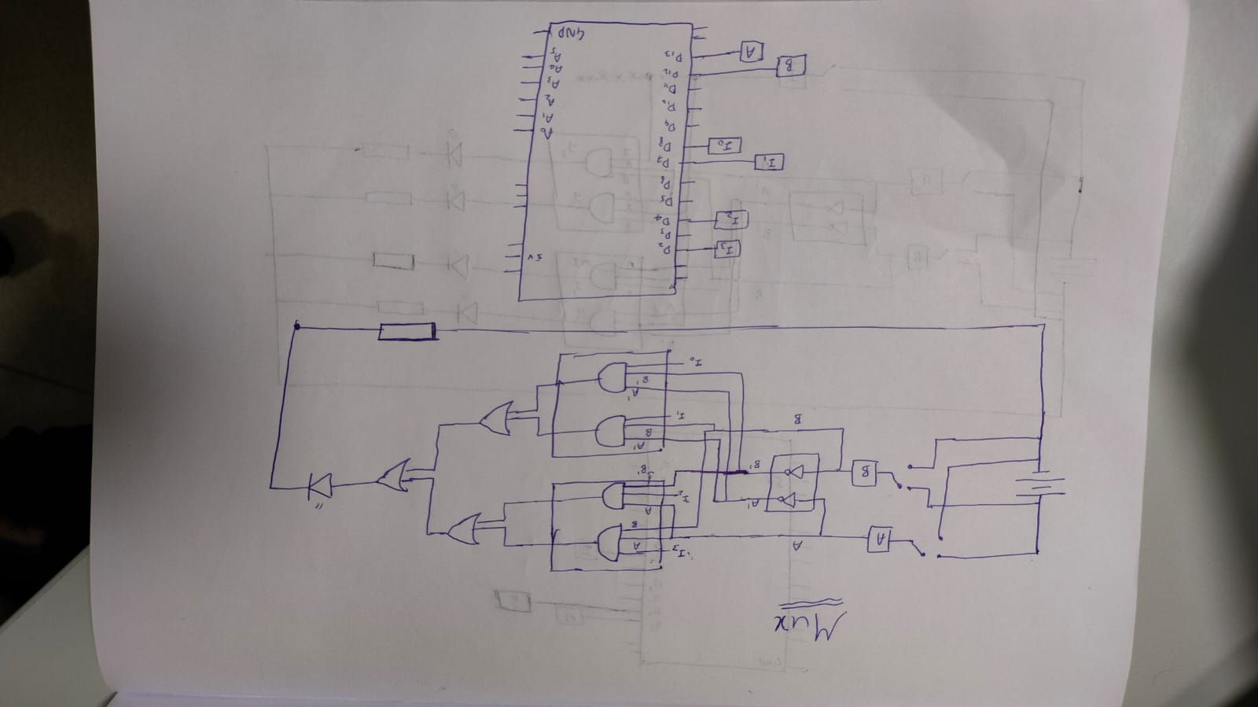

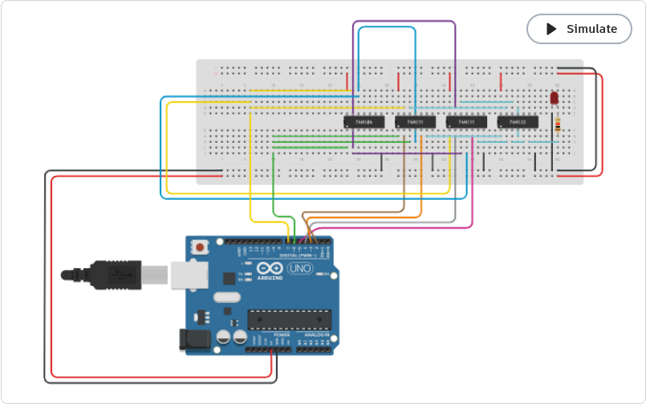

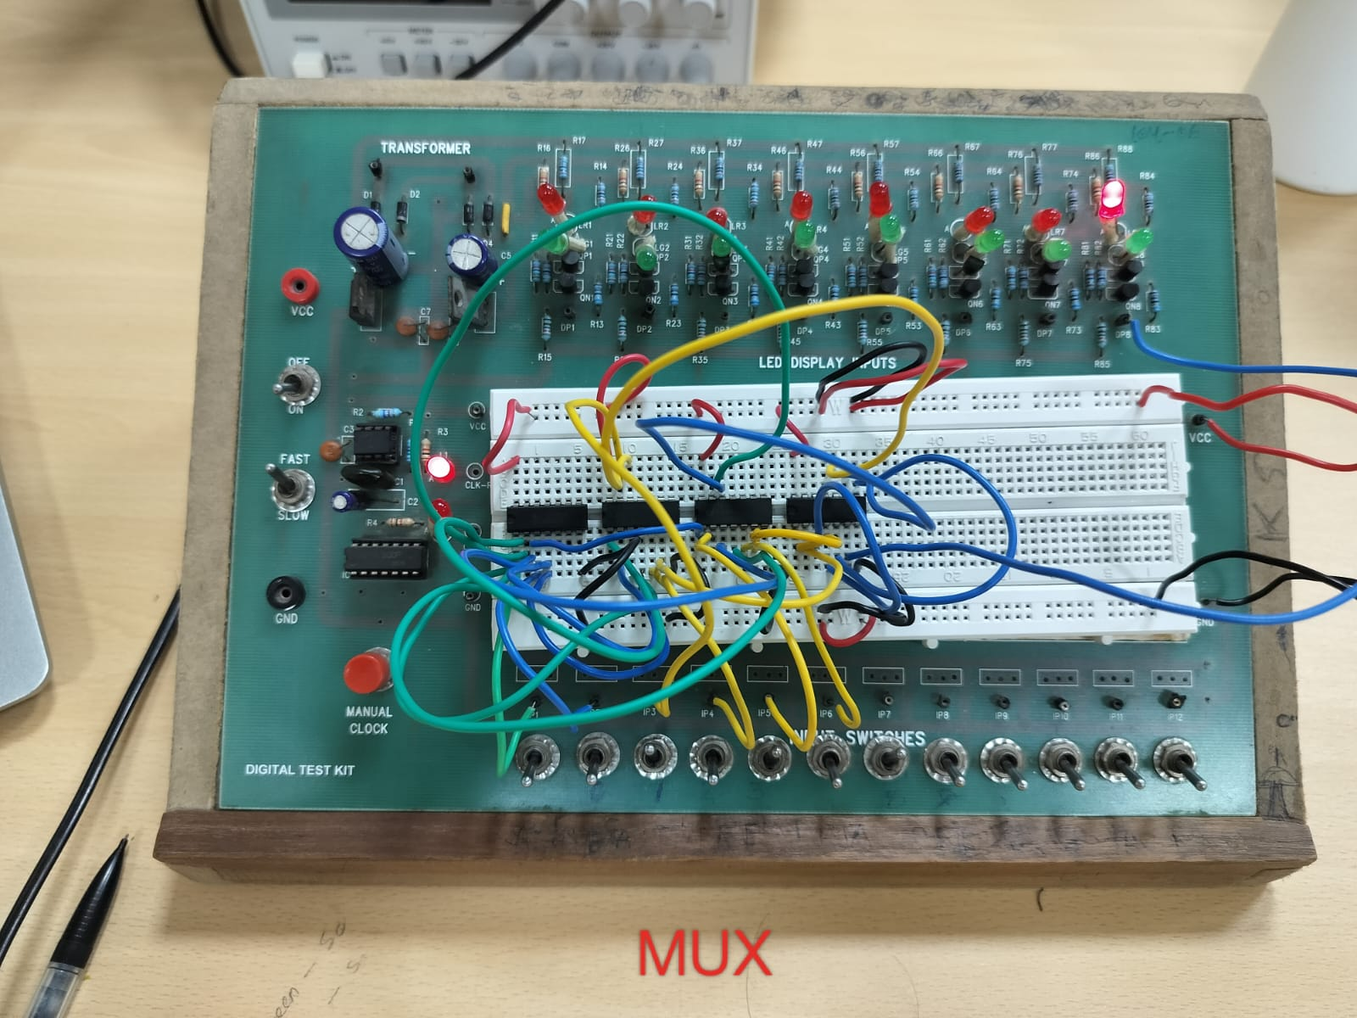

CODE:
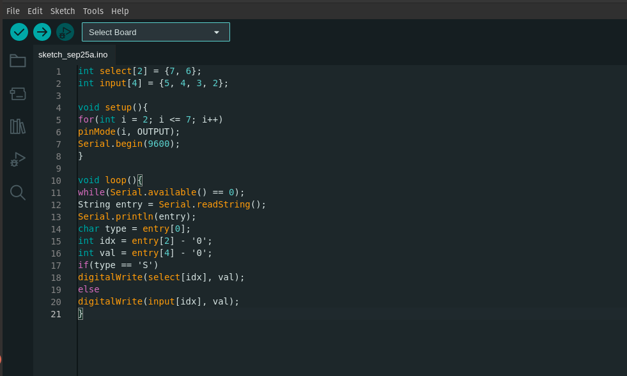

PROCEDURE:
1. The +/- to 5V / GND ports on the Arduino board should be used to power
the breadboard. Afterward, connect the ICs to the VCC and GND ports to
power them.
2. From the Arduino's digital ports, we must take inputs and select lines.
one output channel and four input channels.

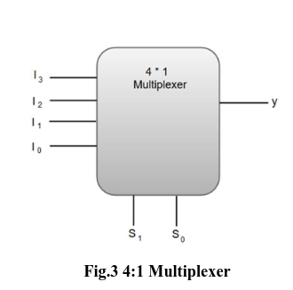

3.Three inputs Those entering the MUX are represented by I3, I2, I1, and
I0, and S1 and S0 denote the select lines that handle the input transferred
to the output
The select lines S1 and S0's four input combinations, 00, 10, 01, and 11,
respectively, switch the inputs I0, I1, I2, and I3 to the output.

4. Y = I0(S1')(S0') + I1(S1')(S0) + I2(S1)(S0') + I3(S1) is the final expression
for Y. (S0)
5. Connect S1, S0 to NOT gates to produce S1' and S0', which are then
employed in AND gates, in order to obtain this expression utilizing gates.
ii. This uses four 3-input AND gates. The first AND gate contains the
following inputs: I0, S0', S1'; second AND gate: I1, S0, S1'; third gate: I2,
S0', S1; and fourth AND gate: I3, S0, S1.
Our input combinations of 00, 10, 01, and 11 switch the inputs I0, I1, I2,
and I3 to the output on the select lines S1 and S0, respectively.
6. Y = I0(S1')(S0') + I1(S1')(S0) + I2(S1)(S0') + I3(S1) is the final expression
for Y. (S0)
7. Connect S1, S0 to NOT gates to produce S1' and S0', which are then
employed in AND gates, in order to obtain this expression utilizing gates
ii. This uses four 3-input AND gates. The first AND gate contains the
following inputs: I0, S0', S1'; second AND gate: I1, S0, S1'; third gate: I2,
S0', S1; and fourth AND gate: I3, S0, S1.

Observation:
Observe the output for each combination of select lines. Verify the
multiplexer function by tabulating the values of the outputs for all input
combinations.
All the possible inputs are run through the Serial Monitor and
observations are as follows:

S1 | S0 | Y
0 | 0 | I0
0 | 1 | I1
1 | 0 | I2
1 | 1 | I3

Conclusion:
This shows how 4:1 MUX works using basic logic gates, and how
those inputs can be handled through the select lines.

TinkerCad Simulations Link:

https://www.tinkercad.com/things/9oyXsPRzyLg-mux/editel?sharecode=bw5w-up4slGrL8hm0kJNvp9gpq0zk15y59GVin1Sz3k

PART B - DEMULTIPLEXER

Objective:
I. construct a 1:4 demultiplexer with fundamental logic gates.
II. Tabulate all of the output of select line combinations S1, S0 to
confirm the DEMUX function.

Required Electronic Components:
Digital Test Kit, which includes a breadboard, red-green LED
outputs, a DC power supply, and other components Three ICs make up the
Arduino UNO R3 (with VCC and GND, i/o ports, a connector for the
Arduino and a PC), two of which are 3-input AND gates (7411) and one is a
NOT gate (7404).

1.Connecting Wires
2.Breadboard
3.Red LED
4.Arduino UNO R3 (with VCC and GND, i/o ports)
5.Connector for the Arduino and PC, four ICs, two consisting of 3-input AND gates (7411) , one consisting of NOT gates (7404).

Reference Circuit:

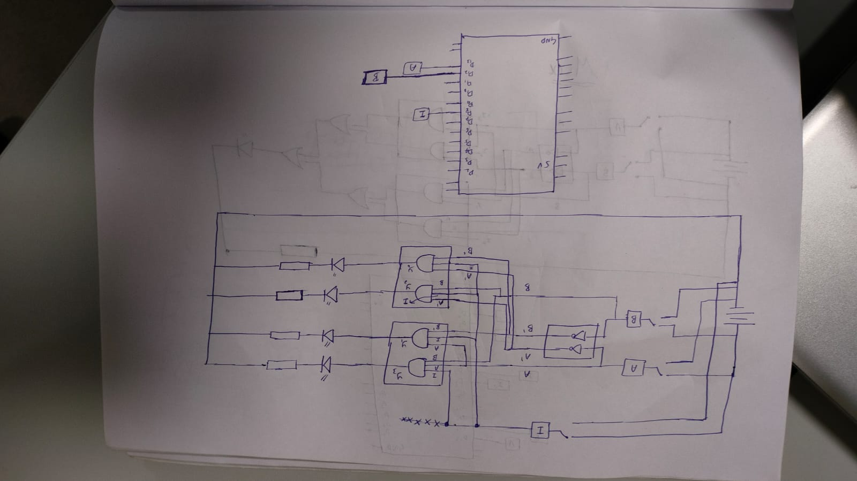

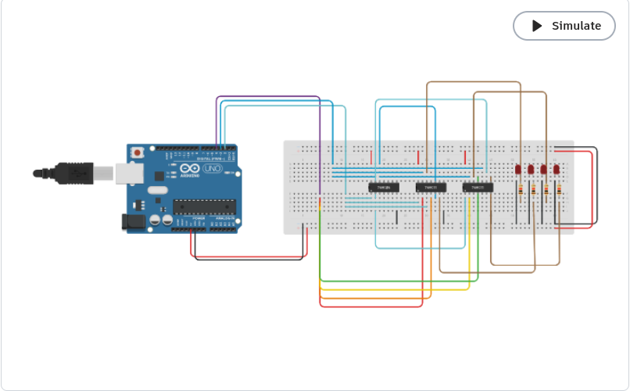

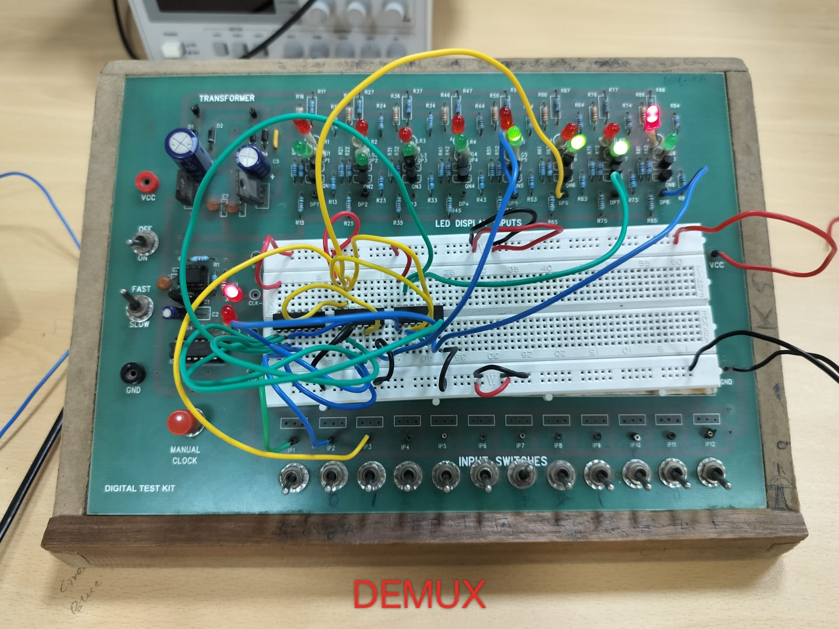

CODE :
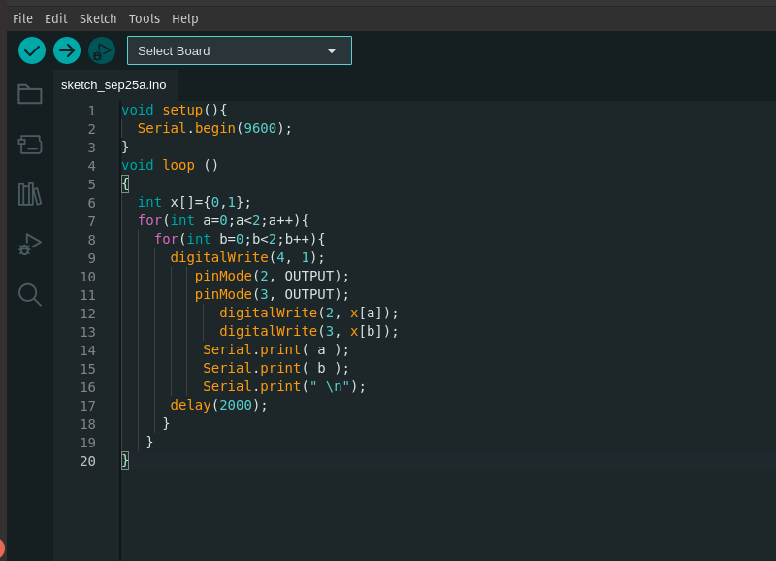

Procedure:
1. We should the power the breadboard by connecting the +/- to 5V /
GND ports on the Arduino board. And then power the ICs by
connecting them to the VCC / GND ports.
2. We have to take one input I and two select lines S1 and S0 from the
digital ports of Arduino.
In this case, there are 4 channels of output, and only one input, where select
lines decide to which channel the input goes.

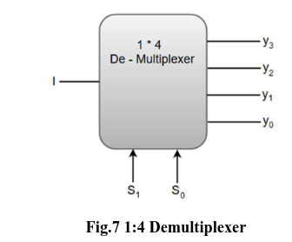

3.The input to the output channels y0, y1, y2, and y3 is switched by four input
combinations on the select lines S1 and S0, which are 00, 10, 01, and 11. The output
channels' final equations are y0 = I(S1')(S0'), y1 = I(S1')(S0), y2 = I(S1)(S0'), and y3 =
I(S1) (S0)
4. Connect S1, S0 to NOT gates to produce S1' and S0', which are then employed in
AND gates, in order to obtain the aforementioned expressions.
ii. This uses four 3-input AND gates. The first AND gate has the inputs I, S0', S1', the
second AND gate has the inputs I, S0, S1', the third gate has the inputs I, S0', S1, and
the fourth AND gate has the inputs I, S0, S1. (With I serving as the common input)
(Input locations are in 1, 2, 13, output ones are in 3, 4, 6, and 11, 10, 9,output 8)
5. Pick four of the LED display ports DP 1–8 and connect each AND gate output to a different LED in the specified order (y3, y2, y1, y0 for our convenience)
6. From the Arduino's Serial Monitor, we still need to take inputs for the common input and two select lines (S1, S0).
7. To accomplish this, we can programme the Arduino board with the code listed below.
i. The Serial.read() function is used to read inputs from the Serial Monitor.
ii. And outputted using the function digitalWrite(port, OUTPUT).
For each combination of the chosen lines, observe the output. By tabulating the values
of the outputs y0, y1, y2, and y3 for all input combinations, you can confirm the
demultiplexer function.

Observation:
All the possible select line inputs are run through the Serial Monitor
and observations are as follows:

S1 | S0 | Y3 | Y2 | Y1 | Y0
0 | 0 | 0 | 0 | 0 | 1
0 | 1 | 0 | 0 | 1 | 0
1 | 0 | 0 | 1 | 0 | 0
1 | 1 | 1 | 0 | 0 | 0

Conclusion:
this demonstrates the operation of a 1:4 DEMUX utilizing simple logic
gates and the select lines to switch the output channels to the common
input.

TINKER CAD LINK:
https://www.tinkercad.com/things/eDYkD3edn7Y-demux/editel?sharecode=0Vny0yOtWvr3tbi9ldgZJzL5iYpBGhGELI-ruajHe5Q

PART C – MUX AND DEMUX COMBINATION

Objective:
I. Assemble the circuits designed in Part - A & Part – B
II. MUX Input via Arduino's Serial Monitor, and DEMUX output using
LEDs

Electric Components Required:
Digital Test Kit (containing DC power supply, Transformer,
breadboard, red-green LED outputs, etc.), Arduino UNO R3 (with VCC
and GND, i/o ports), connector for the Arduino and PC,
MUX - four ICs, two consisting of 3-input AND gates (7411) , one consisting
of NOT gates (7404) and one consisting of OR gates (7432)
DEMUX - three ICs, two consisting of 3-input AND gates (7411) , and one
consisting of NOT gates (7404)

Reference Circuit:

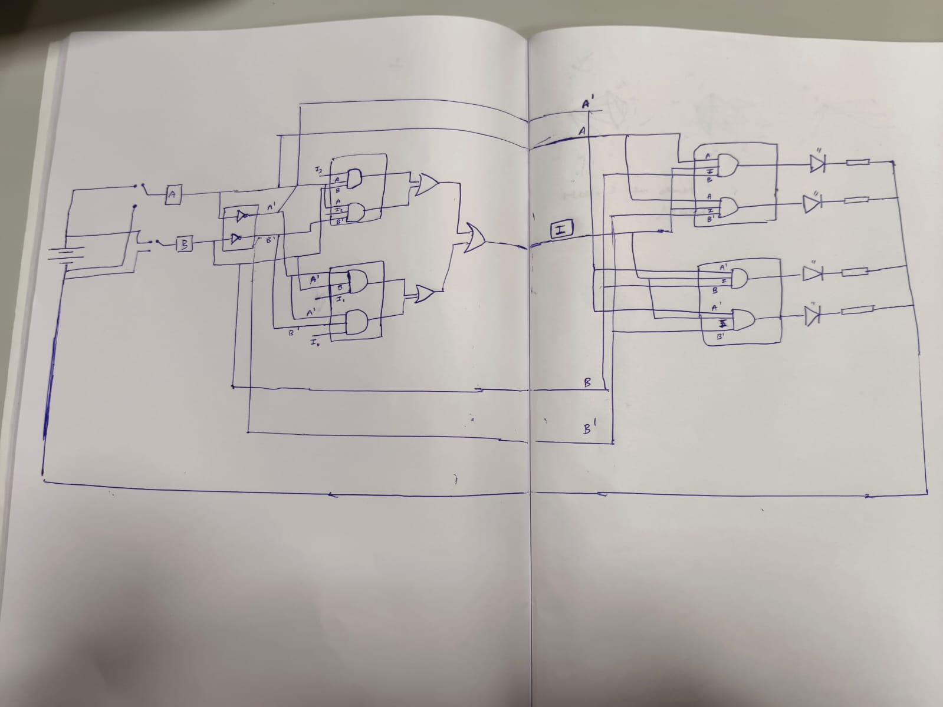

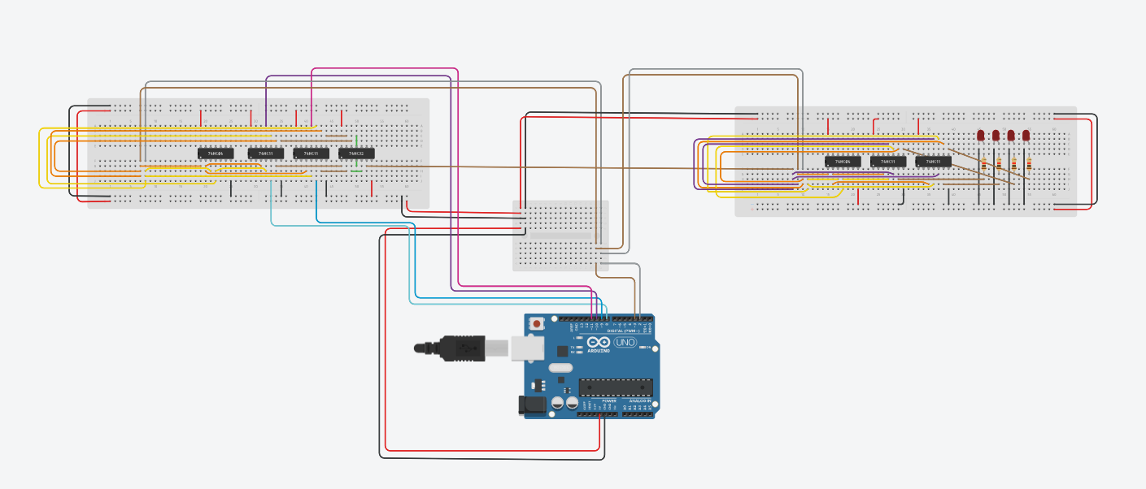

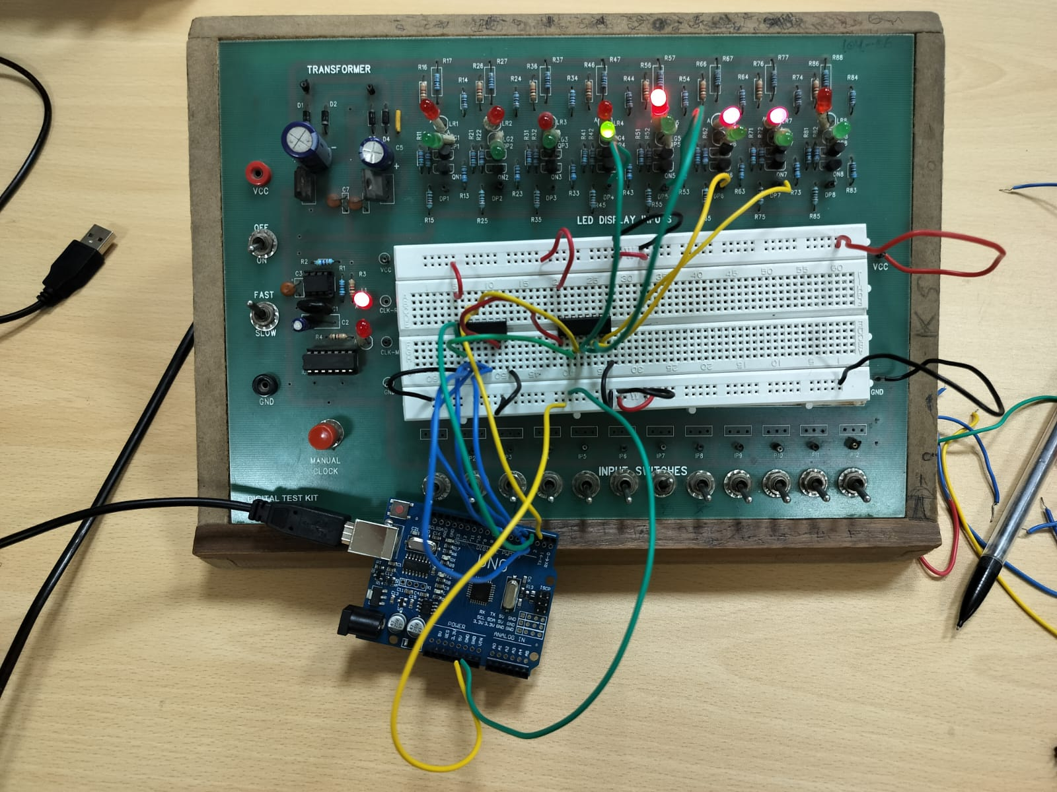

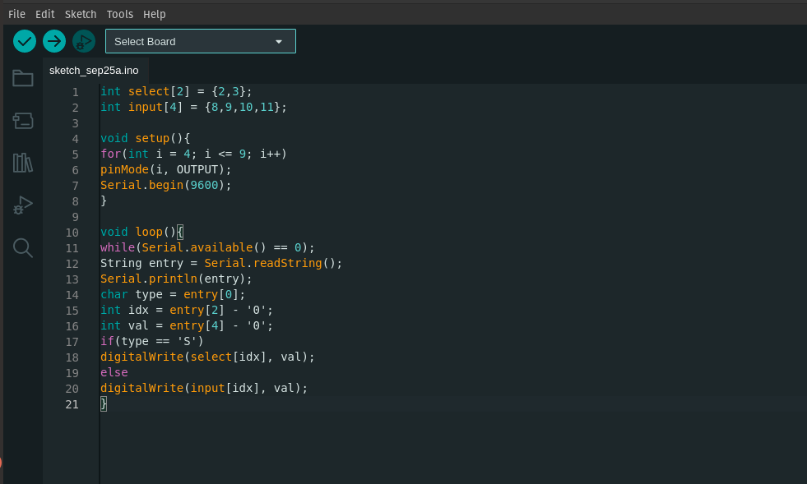

PROCEDURE:
1. This MUX-DEMUX combination has two components.
2. We can utiliZe the same architecture that we built in Part - A for the
MUX component. The DEMUX component that was constructed in Part B
can also be used.
3. We can now integrate this with the DEMUX by coupling the output port
of the MUX's final OR gate to the DEMUX's common input (removing the
second arduino of DEMUX)
4. S1 and S0 are also frequent select lines for MUX and DEMUX,
respectively.
5. Y = I0(S1')(S0') + I1(S1')(S0) + I2(S1)(S0') + I3(S1) is the expression for
the MUX's output (S0)
6. DEMUX outputs are expressed as y0 = I(S1')(S0'), y1 = I(S1')(S0), y2 =
I(S1)(S0'), and y3 = I(S1) (S0)
7. In this case, we merely choose lines and enter values on the Arduino
board. The DEMUX handles the MUX's output because it is connected to
the common input (without any extra code).
Therefore, the code we used to generate the MUX component may also be
used to build the MUX-DEMUX.
For each combination of the chosen lines, observe the output. By tabulating
the output values for all possible input combinations, confirm the
multiplexer-demultiplexer function.

OBSERVATION:
It is seen that the LED outputs from the DEMUX match the inputs entered
in the Arduino Serial Monitor at the MUX.

CONCLUSION:
As a result of using the same select lines, inputs pass via the same channel
and produce the same output at the DEMUX. This demonstrates how to
construct and operate a MUX-DEMUX combo using simple logic gates.

TINKERCAD LINK:
https://www.tinkercad.com/things/aauiS3V0EeK-mux-and-demux/editel?sharecode=JE3sjKSTzJe0ocUbBpDsB3DF7jdFiVXdJIVQAB9_iTM

